**NGERAGEZA SYLVIE**

**Reg:221012636**

**MODULE: JAVA**

**BIT LEVAL 2**

**INDIVIDUAL QUIZES**

**JAVA OBJECT CLASS**

**1.** **class Student{**

**int id;**

**String name;**

**}**

**class TestStudent2{**

**public static void main(String args[]){**

**Student s1=new Student();**

**s1.id=101;**

**s1.name="Sonoo";**

**System.out.println(s1.id+" "+s1.name);//printing members with a white space**

**}**

**}**

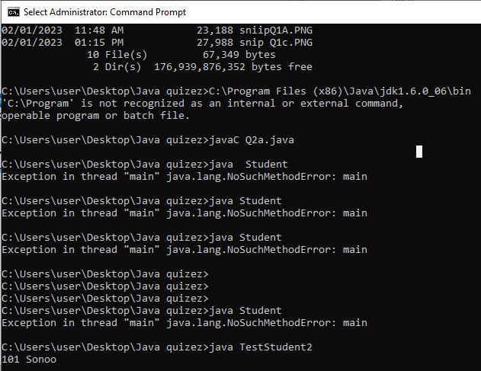

**2. class Student{**

**int rollno;**

**String name;**

**void insertRecord(int r, String n){**

**rollno=r;**

**name=n;**

**}**

**void displayInformation(){System.out.println(rollno+" "+name);}**

**}**

**class TestStudent4{**

**public static void main(String args[]){**

**Student s1=new Student();**

**Student s2=new Student();**

**s1.insertRecord(111,"Karan");**

**s2.insertRecord(222,"Aryan");**

**s1.displayInformation();**

**s2.displayInformation();**

**}**

**}** 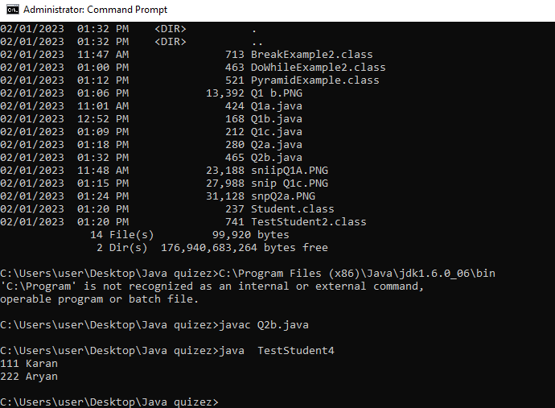

**JAVA INHERITANCE**

**1.** **class Employee{**

**float salary=40000;**

**}**

**class Programmer extends Employee{**

**int bonus=10000;**

**public static void main(String args[]){**

**Programmer p=new Programmer();**

**System.out.println("Programmer salary is:"+p.salary);**

**System.out.println("Bonus of Programmer is:"+p.bonus);**

**}**

**}**

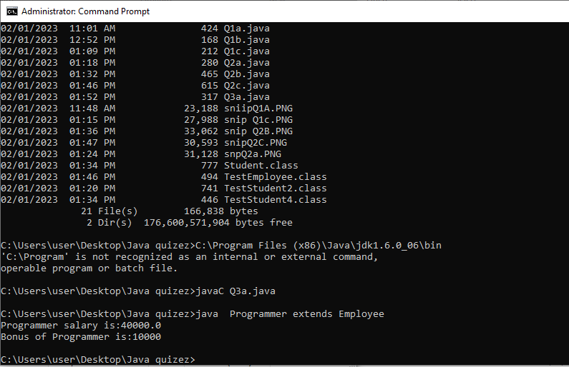

**2,**

class Animal{

void eat(){System.out.println("eating...");}

}

class Dog extends Animal{

void bark(){System.out.println("barking...");}

}

class TestInheritance{

public static void main(String args[]){

Dog d=new Dog();

d.bark();

d.eat();

}}

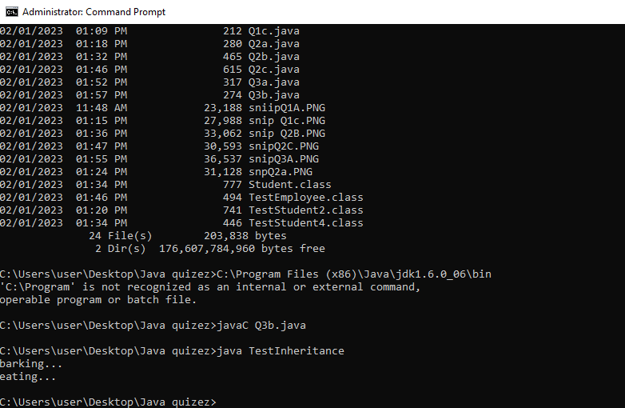

**3.** **class Operation{**

**int square(int n){**

**return n*n;**

**}**

**}**

**class Circle{**

**double pi=3.14;**

**double area(int radius){**

**op=new Operation();**

**int rsquare=op.square(radius);**

**return pi*rsquare;**

**}**

**public static void main(String args[]){**

**Circle c=new Circle();**

**double result=c.area(5);**

**System.out.println(result);**

**}**

**}**

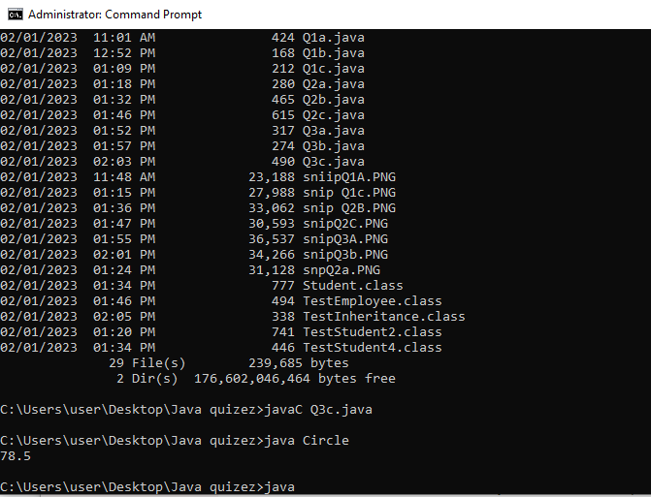

**CONROL STATEMENTS**

1. class BreakExample2 {

public static void main(String[] args) {

for(int i=1;i<=3;i++){

for(int j=1;j<=3;j++){

if(i==2&&j==2){

}

System.out.println(i+" "+j);

}

}

}

}

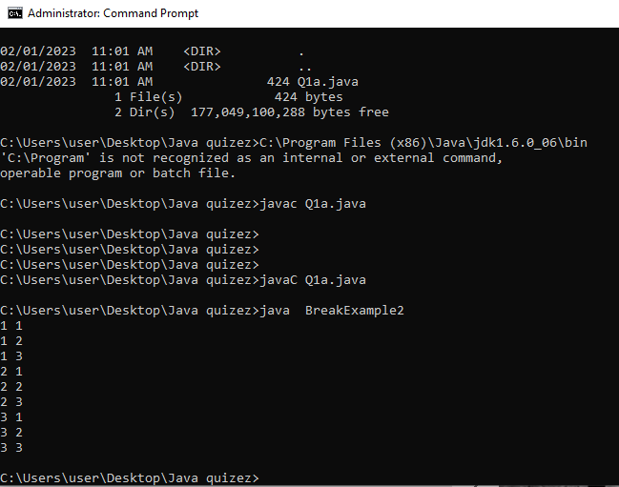

2. class DoWhileExample2 {

public static void main(String[] args) {

do{

System.out.println("infinitive do while loop");

}while(true);

}

}

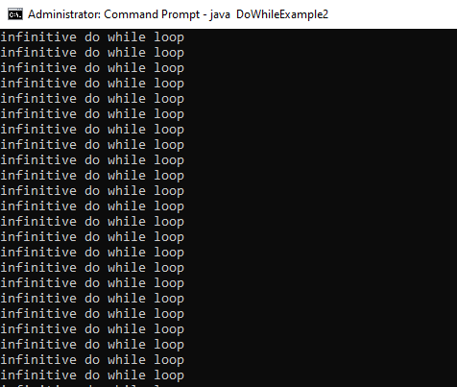

3. class PyramidExample {

public static void main(String[] args) {

for(int i=1;i<=5;i++){

for(int j=1;j<=i;j++){

System.out.print("* ");

}

System.out.println();//new line

}

}

}

**JAVA POLYMORPHISM**

3. class Dog2{

public static void main(String args[]){

Dog2 d=null;

System.out.println(d instanceof Dog2);

}

}

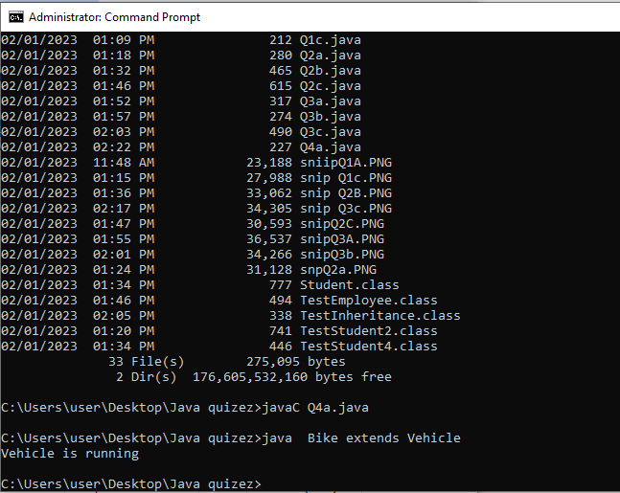

2. class Bank{

float getRateOfInterest(){return 0;}

}

class SBI extends Bank{

float getRateOfInterest(){return 8.4f;}

}

class ICICI extends Bank{

float getRateOfInterest(){return 7.3f;}

}

class AXIS extends Bank{

float getRateOfInterest(){return 9.7f;}

}

class TestPolymorphism{

public static void main(String args[]){

Bank b;

b=new SBI();

System.out.println("SBI Rate of Interest: "+b.getRateOfInterest());

b=new ICICI();

System.out.println("ICICI Rate of Interest: "+b.getRateOfInterest());

b=new AXIS();

System.out.println("AXIS Rate of Interest: "+b.getRateOfInterest());

}

}



3. class Dog2{

public static void main(String args[]){

Dog2 d=null;

System.out.println(d instanceof Dog2);

}

}

